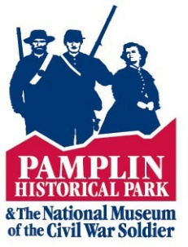
PAMPLIN HISTORICAL PARK
COLLECTION IMAGES SERVICES FEES

Please complete this form and return for evaluation via email or mail to: Pamplin Historical Park, Attn: Collections, 6125 Boydton Plank Road, Petersburg, VA 23803

Name: ____________________________________________________________
Image(s) Requested: (please include object number if known, ex: 2020.001.123)
________________________________________________________________________________________________________________________________________________________________________________________________________________________________________________________________________________________________________________________
Intended Use of Image(s):
______________________________________________________________________________________________________________________________________________________________________________________________________________________________________________________________________________________________________________________________________________________________________________________________________
Deadline to Receive Image(s) by: ___ /___ /___
Email Address: _______________________ Phone Number: (____) ____-_______
Do you wish to receive the images via email or mailed on a CD?
EMAIL CD
If you are having images mailed to you on CD, please provide your mailing address:
__________________________________________________________________________________________________________________________________________________________________________________________________________________________________________

Method of shipping: First Class U.S. Mail ($10.00)
Fed Ex Overnight ($30.00)

Will you be using these images for Personal Use*, or for Public? *If you select ‘Personal’ please skip to the end of this form to sign and date
PERSONAL PUBLIC

Will images be used for:
Editorial Use Online Video
Exhibition Advertising Other
If ‘Other’ please describe:
____________________________________________________________________________________________________________________________________________________________

Project Title:___________________________________________________________________
Proposed Publication/Exhibition Date: ___ / ___ /___
Approximate number of copies to be produced or distributed:______________

Pamplin Historical Park must approve any manipulations to images provided including cropping and color editing, if you intend to edit the image in any way, please describe here:
____________________________________________________________________________________________________________________________________________________________
Are you a For-profit or Non-profit Entity? If Non-profit, please attach proof of status such as an IRS tax-exempt certificate or letter of exemption.
For-Profit Non-Profit

Printed Name:_________________________________________________________________
Signature:_____________________________________________________ Date: __ / __ / __

