Pamplin Historical Park announces spring hours

FOR IMMEDIATE RELEASE
February 14, 2017

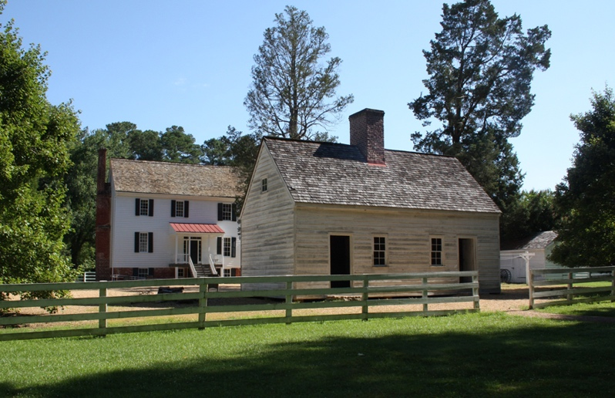
Petersburg, Va. – Pamplin Historical Park and The National Museum of the Civil War Soldier will be open daily, resuming regular operating hours from 9:00 a.m. to 5:00 p.m. beginning Monday, February 27. The Park is currently observing its winter weather schedule, during which it is open to the public on Saturdays and Sundays from 9:00 a.m. to 5:00 p.m. Groups of ten or more may request a reservation for a personalized tour any day of the week.

Image caption: Tudor Hall antebellum plantation, one of several historic homes at Pamplin Historical Park

# # #

One of “Virginia’s Best Places to Visit” according to the Travel Channel, and designated as a National Historic Landmark, Pamplin Historical Park & The National Museum of the Civil War Soldier is a 424-acre Civil War campus located in Dinwiddie County, Virginia offering a combination of high-tech museums and hands-on experiences. The Park has four world-class museums and four antebellum homes. The Park is also the site of The Breakthrough Battlefield of April 2, 1865 and America’s premiere participatory experience, Civil War Adventure Camp. For more information, please call 804-861-2408 or visit www.pamplinpark.org.

