Pamplin Historical Park to host Christmas themed tea
FOR IMMEDIATE RELEASE
November 8, 2016

Petersburg, Va. – On Saturday, Dec. 3, Pamplin Historical Park offers a glimpse into the traditions of Christmas past.

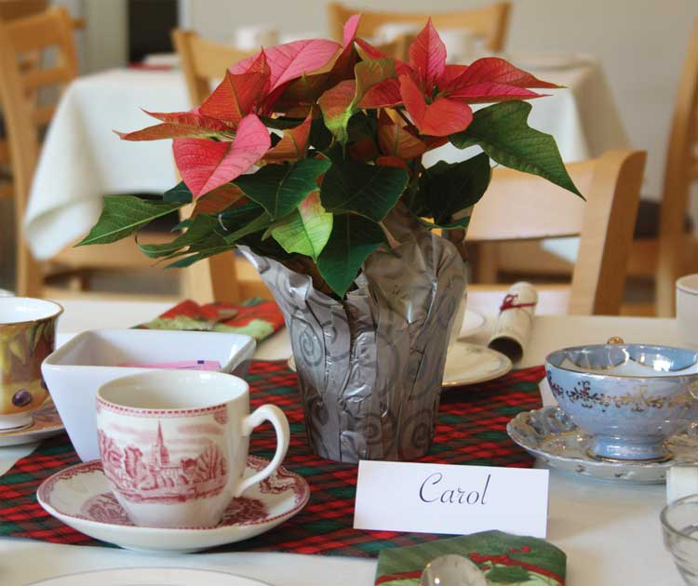
At Pamplin Historical Park’s Tea & Tidings event, guests will enjoy gourmet holiday teas and tasty treats while ladies and gentlemen in period dress will teach guests 19th century holiday traditions. Attendees will also learn about the history and customs of Christmas during the Civil War era, including traditional Christmas carols and stories.

“Gathering with family and friends around special times of the year was important throughout history. This is an opportunity to step back in time and experience how people in the 19th century celebrated the holiday, and to see how many of our modern observances are based on earlier traditions,” says Director of Membership Amanda Bennett.

Tea and Tidings will be held the afternoon of Saturday, Dec. 3 at 2:00 p.m. Reservations and prepayment are required as space is limited for this popular event. The event will be held at The National Museum of the Civil War Soldier located at 6125 Boydton Plank Road, Petersburg, Va. 23803. Tickets are $22 for the general public and $20 for Park Members. Call 804-861-2408 for reservations.

# # #
One of “Virginia’s Best Places to Visit” according to the Travel Channel, and designated as a National Historic Landmark, Pamplin Historical Park & The National Museum of the Civil War Soldier is a 424-acre Civil War campus located in Dinwiddie County, Virginia offering a combination of high-tech museums and hands-on experiences. The Park has four world-class museums and four antebellum homes. The Park is also the site of The Breakthrough Battlefield of April 2, 1865 and America’s premiere participatory experience, Civil War Adventure Camp. For more information, please call 804-861-2408 or visit www.pamplinpark.org.

