Pamplin hosts landmark 20th annual Civil War Symposium
Pamplin Historical Park reaches an historic milestone
FOR IMMEDIATE RELEASE
October 11, 2016

Petersburg, Va. – Pamplin Historical Park and The National Museum of the Civil War Soldier will host its landmark 20th annual Civil War symposium October 14-16. Nearly 100 distinguished historians and scholars will gather at the Park to study and discuss one of the most turbulent chapters in American history. The symposium will feature lectures and discussions on topics significant to understanding the American Civil War, from the emotional lead-up to war to Reconstruction.

Pamplin Historical Park has hosted this nationally-renowned symposium since 1997, just three years after the Park’s founding. The event is held annually at the Park’s Education Center, which was specially built in 2005 to accommodate the symposium as well as the many educational classes, school groups, and meetings the Park hosts each year. Earlier symposium weekends were held at local conference centers. From the very beginning, this event has attracted some of the country’s most respected Civil War scholars. Attendees from nearly every state and from as far away as Europe have come to participate in this special weekend.

This year’s faculty list features eight renowned Civil War experts, including Pulitzer Prize winner James McPherson, William Blair from Penn State University, historian and scholar Robert Girardi, Earl J. Hess from Lincoln Memorial University, author and historian William Marvel, George C. Rable from the University of Alabama, author Dennis Rasbach and Mark W. Summers from the University of Kentucky. All of the speakers are noted experts on their topics, and each of them have recently published books available. Their books will also be available for purchase and signing throughout the event.

Selected program topics include Civil War infantry tactics, the Northern image in the Confederate mind, and a new twist on the 14th Amendment. Notable personalities from the Civil War such as Gouveneur K. Warren, Edwin M. Stanton, Joshua Chamberlain, Abraham Lincoln and Jefferson Davis will be discussed in depth at the three-day event. Symposium participants will interact closely with the speakers throughout the weekend, take a detailed tour of the Civil War Petersburg and the Crater on Friday, October 14, and enjoy a Sunday open forum panel discussion with all of the speakers featured.

The 20th Annual Civil War Symposium runs from Friday evening’s opening reception through Sunday afternoon’s panel discussion. Reservations are required to attend the symposium. A reception and dinner with the speakers will be held on Friday, October 14^{tt}. Guests do not need to be registered for the symposium in order to reserve space for the dinner. For more information, call 804-861-2408 or visit www.pamplinpark.org/events.html.

# # #

One of “Virginia’s Best Places to Visit” according to the Travel Channel, and designated as a National Historic Landmark, Pamplin Historical Park & The National Museum of the Civil War Soldier is a 424-acre Civil War campus located in Dinwiddie County, Virginia offering a combination of high-tech museums and hands-on experiences. The Park has four world-class museums and four antebellum homes. The Park is also the site of The Breakthrough Battlefield of April 2, 1865 and America’s premiere participatory experience, Civil War Adventure Camp. For more information, please call 804-861-2408 or visit www.pamplinpark.org.
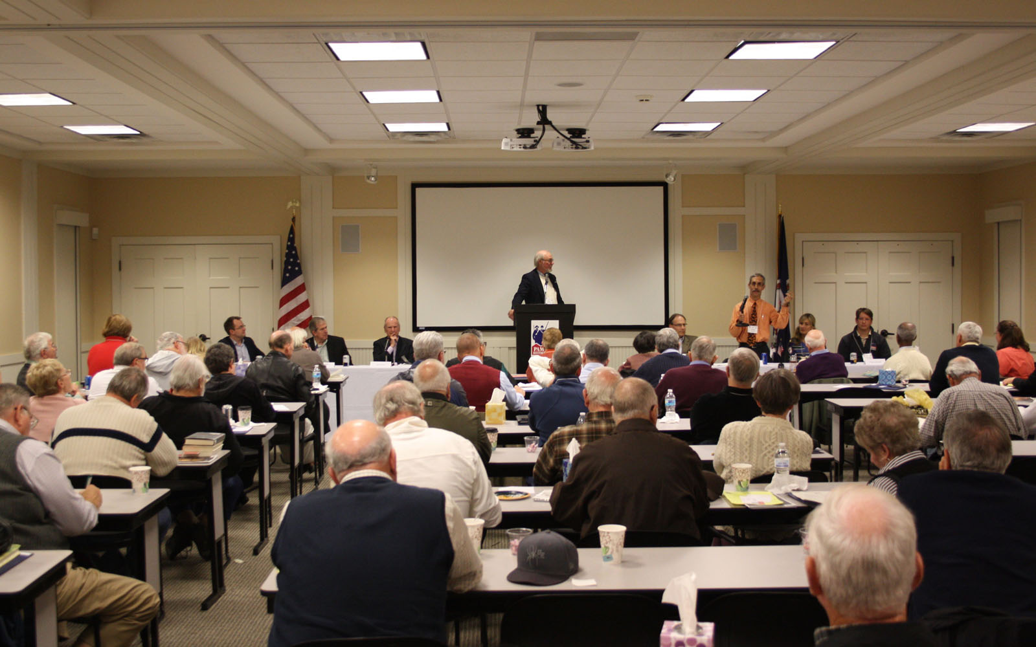

The panel discussion at Pamplin Historical Park’s annual Civil War Symposium.

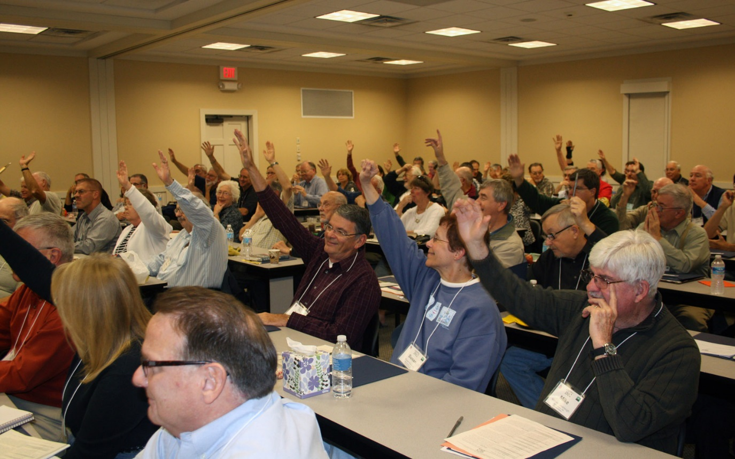

Symposium attendees gather to study the legacy of the American civil war at Pamplin Historical Park.

