Pamplin Historical Park announces winter hours
FOR IMMEDIATE RELEASE
November 23, 2016

Petersburg, Va. – Pamplin Historical Park and The National Museum of the Civil War Soldier will be operating on its winter schedule from Monday, November 28 through Sunday, February 26, 2017. During this period the Park will maintain full operating hours and programming for visitors on Saturdays and Sundays only, operating from at 9:00 a.m. until at 5:00 p.m. Park staff will also continue to serve group activity by reservation for any day of the week. Contact Pamplin Historical Park’s group bookings specialist for more information at 804-861-2408 or visit www.pamplinpark.org.

In order to accommodate visitors around the holidays, Pamplin Historical Park will be open daily during the days between Christmas and New Year’s Day, December 26-31, 2016. The Park is closed on Christmas and New Year’s Day.

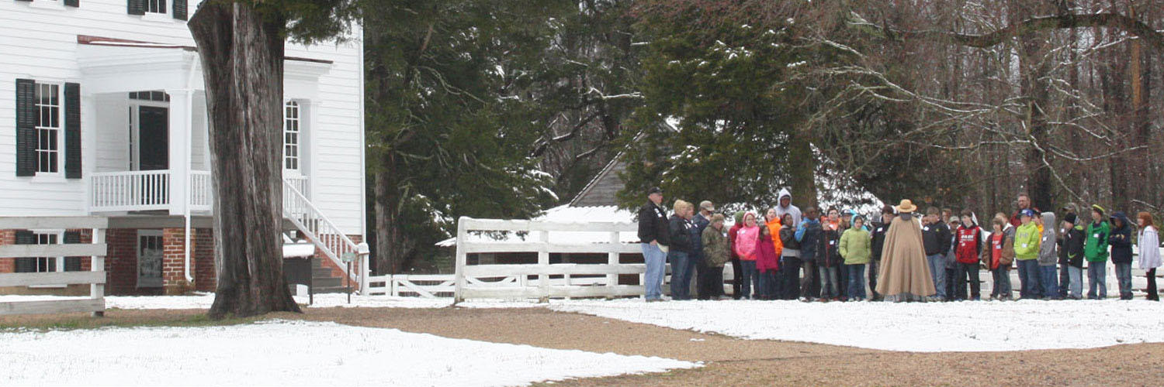

# # #

One of “Virginia’s Best Places to Visit” according to the Travel Channel, and designated as a National Historic Landmark, Pamplin Historical Park & The National Museum of the Civil War Soldier is a 424-acre Civil War campus located in Dinwiddie County, Virginia offering a combination of high-tech museums and hands-on experiences. The Park has four world-class museums and four antebellum homes. The Park is also the site of The Breakthrough Battlefield of April 2, 1865 and America’s premiere participatory experience, Civil War Adventure Camp. For more information, please call 804-861-2408 or visit www.pamplinpark.org.

